SOFE 4790 Distributed Systems (Fall 2021) – Assignment 1 Report

**GitHub Repository link:** <https://github.com/Janahan10/SOFE4790-Distributed-Assignments>

For my application I created five services that incorporate multiple different tasks that often done separately. The first service that is provided to the user is a simple date service which when it is called returns the current date to the user. This was tested by first debugging by printing the date returned by the java module the LocalDateTime, and in the correct format by using the DateTimeFormatter. For the second service, I utilized a service that was used in assignment 1 which was the quadratic solver. This service takes 3 numbers from the user representing the a, b, and c coefficients of a quadratic equation. This service returns the roots of the equations as a string or tell the user there is no roots by testing the determinant. For the third service I created a string reversing service which prompts the user for a string and returns the reversal of that string. Fourth service is a binary number converter, which takes a decimal base number and returns the binary equivalent. This was tested by sending various values that are valid binary numbers as well as sending an empty number. For the final service I created a bracket balance checker, where it checks if an equation has matched brackets and no extra brackets. This was tested by sending a valid bracket string and not valid string with extra brackets.

*Screenshot #1: Test of Date Service*

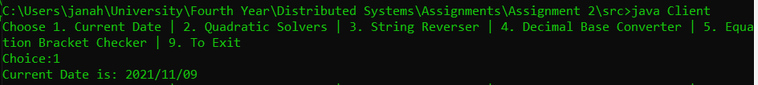

*Screenshot #2: Test of Quadratic Equation Solver Service*

*Screenshot #3: Test of String Reversing Service*

*Screenshot #4: Test of Binary Number Converter Service*

*Screenshot #5: Test of Bracket Balance Service*

